# **User Guideline for WUW On Demand Home Service App**

1. Firstly, user must create account or if the user already has account then they can directly login.

1. User must fill all the information such as name, phone number, password in order to register.

1. User must verify their account After verifying your phone number you will be sent a code on your phone. After receiving the code, you will be automatically redirected to the booking page.

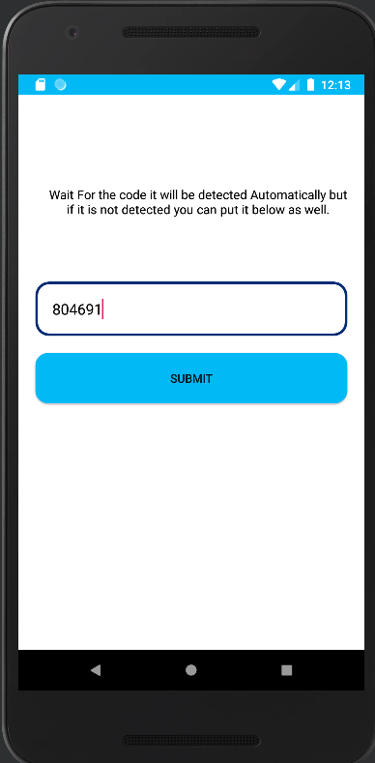

1. After otp verafication now user can login after login user will redirect to booking page

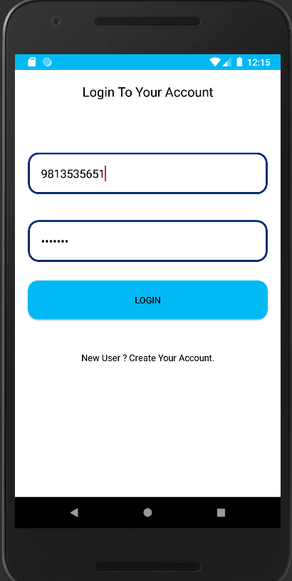

1. After login user can now book the services as per their requirements

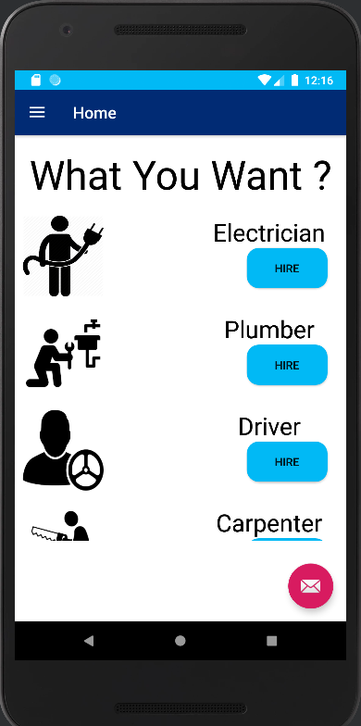

1. Now user can share their location so that the service provider can find their location and user can pay the amount to the service provider trough paypal or cash system.

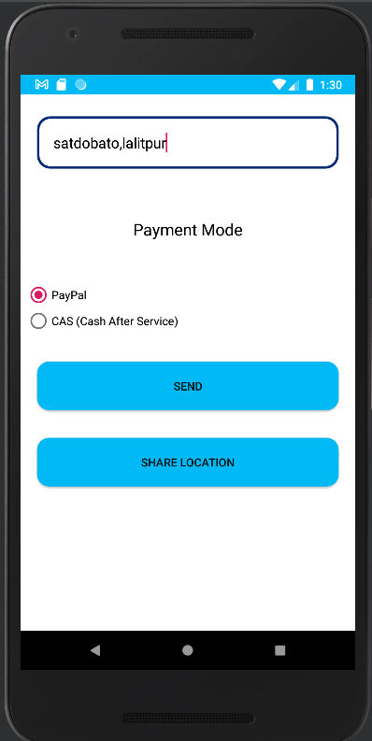

1. User can also chat and give feedbacks to the service provider through email.

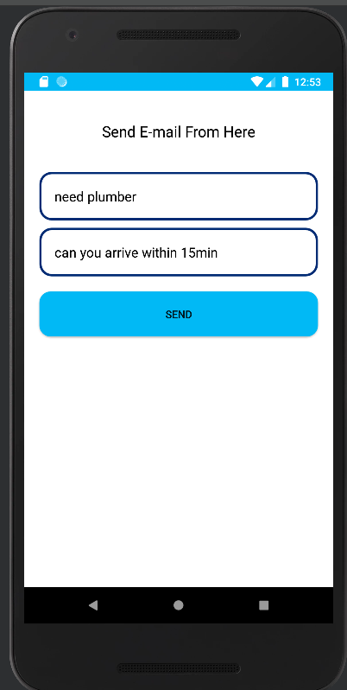7

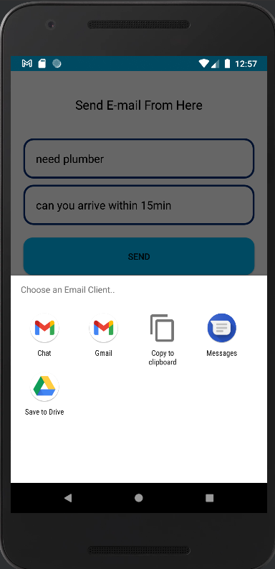

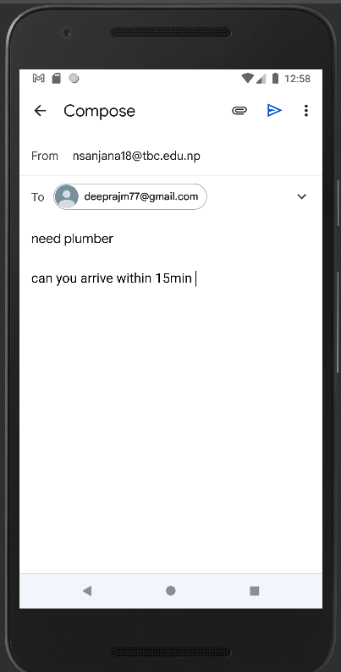

1. After completing the service user can logout by clicking on logout option and view their payment details through the standard charges option

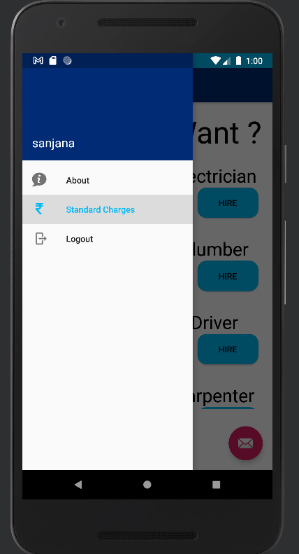

1. User can go to standard charges view the payment details as well

